Presidential Volunteer Service Awards

The Presidential Volunteer Service Awards is a service that HST offers to all of its students who qualify by volunteering their time throughout the year. There are different award levels: bronze, silver, and gold. Each level requires a minimum number of hours to earn that award, and different age groups have different requirements.
Typically, the HST “year” runs from June to May for the volunteers. The log sheet is kept and verified by the parents of the HST student throughout the year. Usually around the pool party (the beginning of June), the log sheets are submitted to the Executive Director who then gives them to an HST volunteer. It is the responsibility of this volunteer to submit the names and hours into the on line database and order the awards (pins and letters). To complete their job, the volunteer must then process and distribute the awards at the mandatory parent meeting in October. If any awards are not claimed, the volunteer must mail them to the recipients.
There is a small fee for each award. As a gift to our students, we will pay for this award. However, if a sibling of an HST student that does not participate in HST wants to have their volunteer hours processed and awarded through HST, there will be a fee of $10 for each award. This fee will not only cover the cost of their award, including the shipping, but will also help defray the cost of the other awards for HST. This money will be handled by the Executive Director and will not be part of your responsibility.
Responsibilities

The following is a comprehensive list of the responsibilities of this job.
- Pick up forms. The forms will be at Marilyn Mullan’s home (400 Broadwood Drive, Rockville, MD 20851) one week after the pool party. The pool party is usually the first week of June. The forms will be in an envelope on a table inside the sunroom clearly marked “Presidential Volunteer Award Forms.” The sunroom is always open to HST members.
- Review applications. You must review the log sheets to make sure that no family chores (babysitting, lawn work, household chores, etc.) are included. This is the policy of HST as well as the Presidential Volunteer Awards. You will then add the hours to make sure your total matches the total submitted by the parents.
- Order the awards. The step by step instructions for this task are listed in the following section.
- Prepare the awards for distribution. When you receive the awards, a personalized letter will come in an envelope with the student’s name on it. First, you must ensure you received all of the awards you ordered. Then you will put the correct pin in this envelope and tape it shut. The award level, along with the student’s name, can be found on the printed receipt you receive when you order the awards. Finally, put all of the envelopes in alphabetical order.
- Distribute the awards. Contact Marilyn Mullan for the responsibilities of distributing the awards.
The following instructions explain how to log into the website, submit the volunteer hours for each student, and order the awards.
Log Into the Website

- Log on to http://www.presidentialserviceawards.gov/
- Click on the words Log In in the top right corner of the screen.
You will now see the Log In page.
- In the Username box type hstpvsa@gmail.com
- Click in the Password box and type XXrFRQ8
- Press Sign In button to get the following screen:
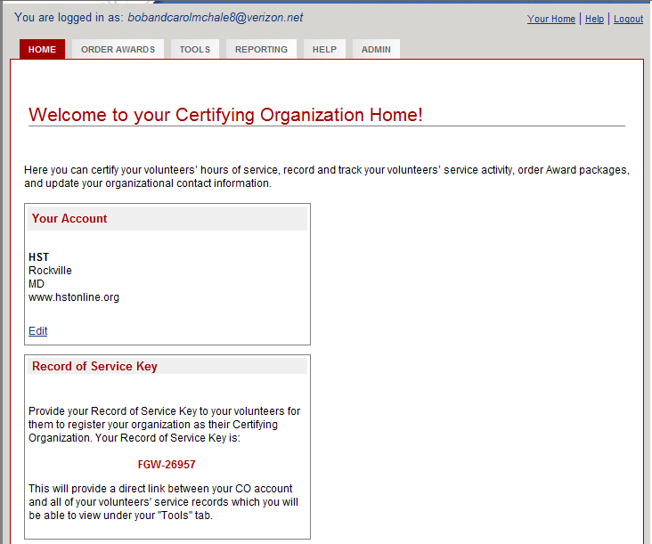
Student Information

HST gives each qualifying person a personalized award. The following steps show you how to enter a student’s name and the total number of hours they volunteered for the past year.
- Click on the Order Awards tab.
HST does not place bulk orders for awards. We have been using the “quick certification” for the past several years. This option allows you to enter just the name and total number of hours.
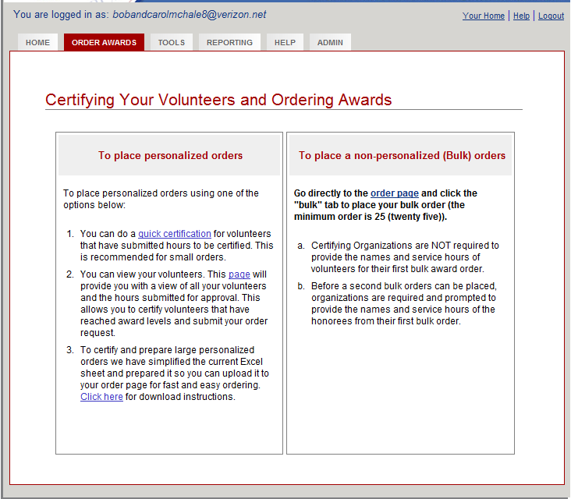
- Click on Quick Certification under the first column titled, “To place personalized orders”.
There are three steps to complete for each order.
Step one:
- Choose the appropriate age group for the individual you are submitting an order for by clicking on the down arrowhead. Then click on the age group found at the top of the hours sheet.
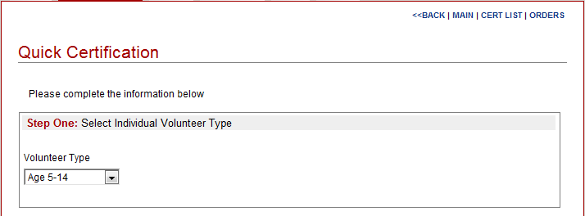
Step Two:
- For section A: Click in the appropriate boxes to type in the first and last name of the volunteer. Make sure you type their name correctly because this is the way it will appear on their letter.
- For section B: Click in the appropriate answer (by default it is No).
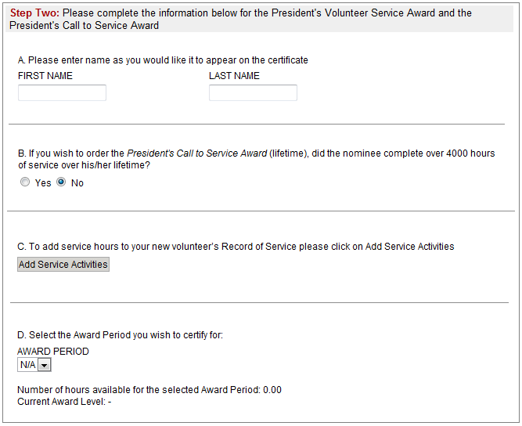
- For section C: Click on the Add Service Activities button. You will see the following boxes.
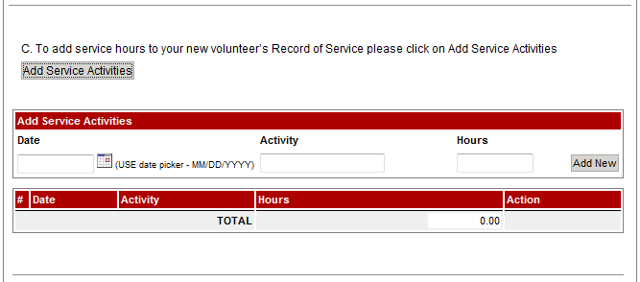
- Click on the calendar picture to choose a date. Normally, the same date will be chosen for each student, such as June 1.
- Click in the Activity box. Type the words Total Hours for 2011-2012 (insert the appropriate years).
- Click in the Hours box. Type in the total number of hours the student performed according to his sheet. (Round total hours to the nearest WHOLE hour)
- Click the Add New button.
- For section D: This defaults to 12/31 of the current year.
You must then choose one of the red box options from the following screen:
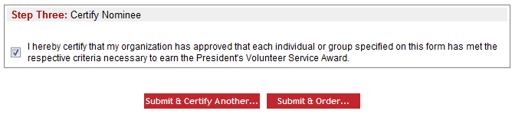
Continue to chick the Click Submit & Certify Another…until all names have been entered. Repeat the above instructions until you record the last student.
After you record the information for the last student, click on the Submit & Order…button.
Ordering Awards

Once you have all of the information typed in, you need to complete the following steps to actually place the order for the awards.
Take a moment to read the instructions under Step 1 of 4: Select the awards you wish to order in the dialog box before you.
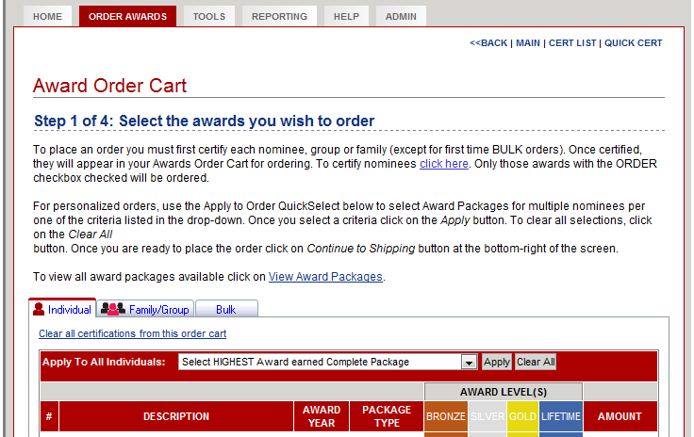
- Select HIGHEST Award earned Complete Package option.
- Click the Apply button.
By choosing the above options, each HST student will automatically receive the highest award they are eligible for.
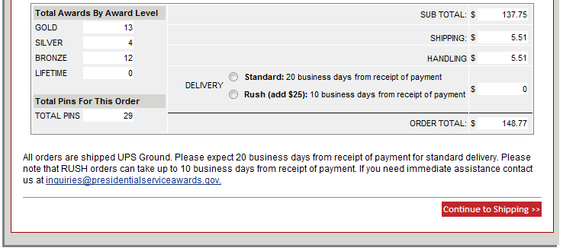
- For the Delivery option, choose Standard shipping.
You will receive the following dialog box. The only option you have is to click the OK button.
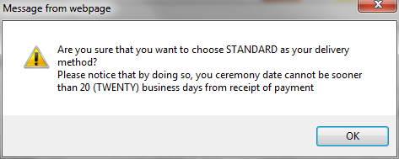
- Click the Continue to Shipping button in the bottom right corner of the dialog box.
You are now in step two of the four step ordering process. If you are shipping them to your home, click on the blue add a new address option in the first paragraph. Then type in the appropriate address.
When you choose a date that you wish to receive your awards, you must put at least 20 days in advance. Typically it does not take that long to receive the awards, but it is a requirement of the organization.
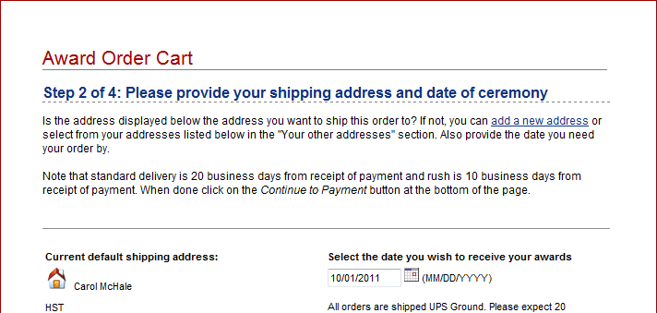
- Now click on Continue to payment.
This will take you to Step 3 of 4: Your Payment.
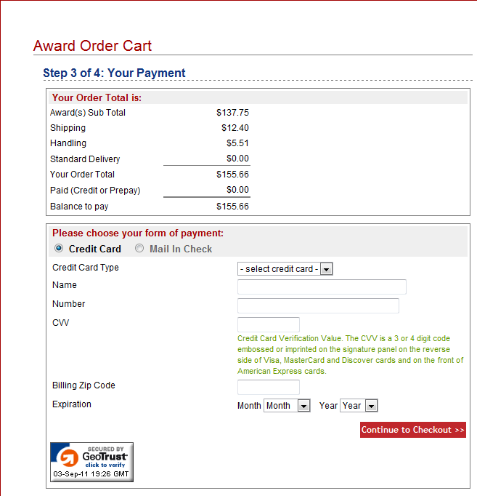
This page will show you how much the awards will cost, including the delivery fee. You must obtain the correct credit card, the credit card number, the CVV, and the expiration date from the Executive Director of HST. Make sure you have the zip code associated with the card, too. (The zip code associated with the card is 20851- Marilyn Mullan’s personal zip code)
- Click on the Credit Card option.
- Type in the required information, ensuring you type the numbers correctly.
- Click on the Continue to Checkout option.
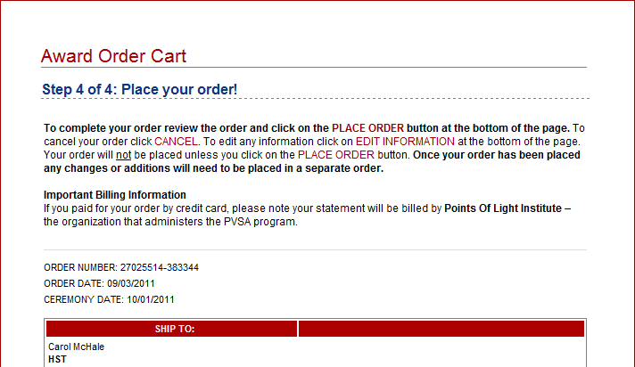
You will be taken to Step 4 of 4: Place you order!
- Review all of the information for accuracy on this page.
- Click the red PLACE ORDER option.
You will receive the following dialog box.
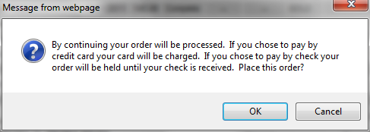
- Click OK
Now that you have officially placed the order, you will receive the following:
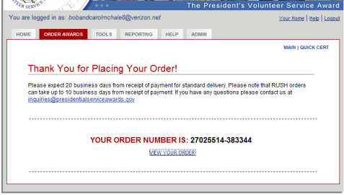
The Executive Director requires a hard copy of the order to show the HST Board of Directors. (Select option to print copy of order/receipt to be mailed to HST, P.O. Box 150, Rockville, MD 20848)
- Click on the View Your Order option.
- Print this page for HST’s records.
Now that you have completed your task, make sure you logout.
- Click the blue Logout option located in the top right part of the your screen.
You will be taken back to the Login Page.
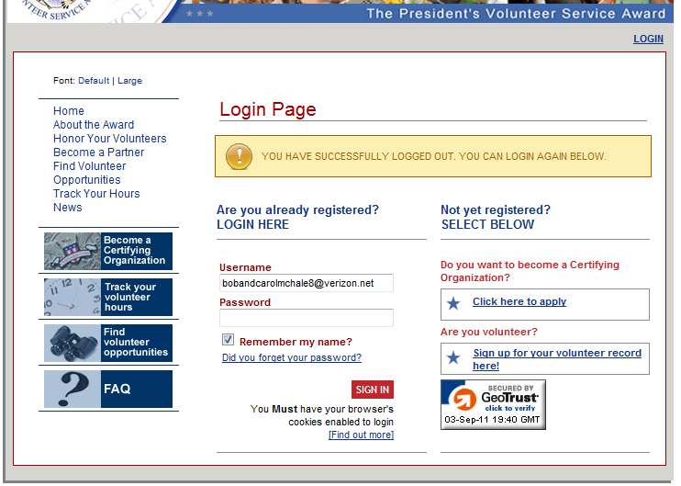
Finally, you should also receive an email confirming your award purchase. This must be forwarded to the Executive Director for HST records.

