**Using the Address Database**

Use these handy tips to maneuver in the HST Address Database.

One **very important** piece of information to keep in mind as you edit and add addresses:

Remember to click the **Change** button () every time you make a change to a record. Otherwise the change will not be made in our database.

You may continue to go back into the database to make changes and add addresses until the campaign ends and all the addresses are locked.

If you have previously entered email addresses and wish to get credit for editing the addresses you have, you must click the pink **Finished** button ().

**Log In**

* Go to  <https://hstfamilies.org/services/mailout.php>
* Type in your TADS Email Address.
* Type in your password. (your password is LastnameZipCode! Example: Stoolmiller20886!)if you have trouble with password text HST at 240-997-5796)
* Click the **Log In** button.
* You will be taken to the Mailout List software.

**Editing a Record**

* Make the necessary changes in the current record.
* Click the change button ().
* A pop-up confirmation box will appear. Click OK.

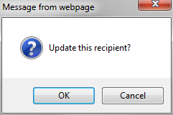

**Adding a Record**

* Click the **Add Recipient** option in the gray bar on the left of the screen.
* Complete the form. Then click the blue **Add User** button at the bottom of the screen.



**Deleting a Record**

* Click the delete button () to the far right of the record you want to delete.
* A pop-up confirmation box will appear. Click OK.

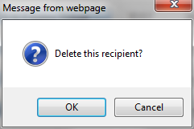

**Completing your Changes**

* Once you have made all of your changes (including additions and revisions), click the pink Finished button.

